Tip Approach

Our Besocke-style scanner is made up of 3 outer piezo and 1 inner piezo. The three outer piezos are symmetrically distributed and each has a tungsten ball at the top to support the sample holder. The piezo in the middle holds the tip, which is our scanner. Three outer piezos can stretch in X, Y and Z directions with offset voltage. Their offset voltage in Z direction is common. We name them Xoffset/Xin, Yoffset/Yin and Zouter respectively. The displacement (voltage value) of the inner piezo has only one direction Z, which is named Zout/Zoffset. It should be noted that there is a little angle between the plane of contact between our sample holder and tungsten balls and the horizontal plane, which will play a key role in the coarse tip approach process. It is worth noting that readers should always pay attention to distinguish between scan mode and tip approach mode to understand how the scanning head works.

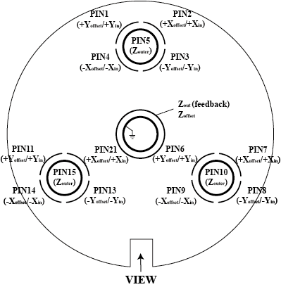

Fig1. piezo configuration (to be added)

Tip approach process can be divided into two steps: giant step and baby step. The giant step is completed by the three outer piezo's rapid twitch in the X and Y directions, and the baby step is completed by the stretching in the Z direction. We expect that giant step can make the sample close to the tip (lower) quickly, while baby step can detect whether the tip approach process is completed, that is, whether the tunneling current reaches the preset minimum value, so as to give an indication for whether to continue approaching.

**In the giant step**, the motion process of the three outer piezo is completed by four steps. **In the first step**, the outer piezo moves along the inclined plane of the sample holder, and the voltage is added as a quadratic curve, which means that the translation may be very fast at the end, and sliding may occur between the sample holder and the tungsten ball; **The second step** is to adjust the position of the outer piezo in the Z direction to make the tip retract, that is, to ramp Zouer to a specified value. At this time, the sample may fall or slide. **In the third step**, after a very short interval (15 microseconds), the X and y of the outer piezo are restored to the original position. Through this step, we restore the piezos’ position in X and Y directions (Xoffset and Yoffset) before the sample lands to contact with the tungsten ball again. **Fourth**, after a long time interval, we restore the Z direction of the outer piezos. The delay is to wait for the sample to fall on the tungsten ball and stabilize. The way we control Zouter is like a biquadratic curve, which ensures that every time Zouter changes at the end is extremely small, so as to maintain the stability of the sample as far as possible. This process is described in code as function *oneGiant* in “TipApproach.c”.

Fig2. sketch of Giant step and Baby step (to be added)

**In baby step**, we need to judge according to the current tunneling current and Zouter's range. If the preset minimum tunneling current value has not been reached and Zouter will not exceed the limit in the next step, we will continue according to the given step size until the minimum tunneling current appears; Otherwise, we’ll set Zouter to the maximum value directly. Finally, we use biquadratic curve to make Zouter return to the initial value. Through the above steps, we can detect whether the tunneling current exists within the limit of Zoffset. If it exists, tip approaching is completed, otherwise we will proceed to the next round of giant step. Function of this part is called *babyStep* in the code, which finally returns the flag of whether to continue approach.

Two ways to output voltage

Functions *parabSlide* and *parabSteady* describe two ways to output voltage to piezo. *parabSlide* ramps an output channel with a parabola function and ends with high speed. The target value and the second derivative are defined by user. *parabSteady* ramps an output channel with two parabola functions and ends with near 0 speed. The target value and the second derivative are defined by user, too. And in the second parabola stage, the second derivative is also the minimum speed at the end.

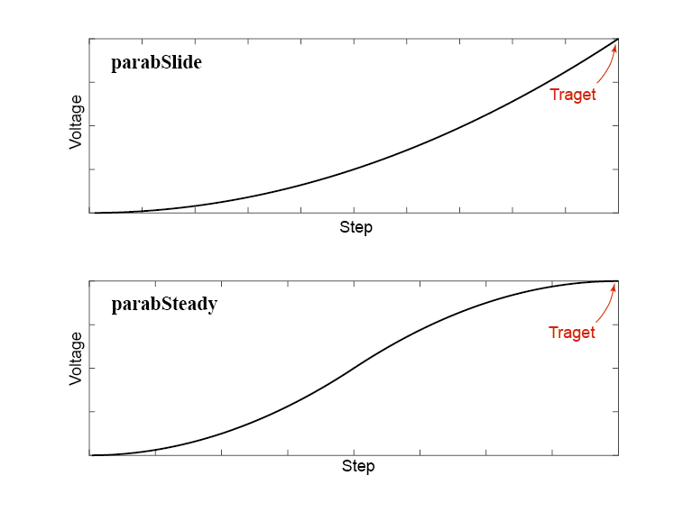

Fig3. sketch of parabSlide and parabSteady (to be added)